CHAPTER 14

quality and environmental
cost management

discussion questions

1. Quality of design is a function of the product’s specifications, whereas quality of conformance is a measure of how a product meets its specifications.
2. All quality costs are incurred because poor quality may or does exist.
3. The zero-defects approach emphasizes conforming to specifications. Upper and lower limits are set for product variation, and any unit that falls within those limits is deemed acceptable (units outside the range are defined as defective). The robust quality
approach emphasizes “fitness for use.” There is no range within which variation is acceptable. Thus, any unit not meeting the target is defective.
4. Under the robust quality approach, any variation from the ideal entails a loss, a loss which grows larger as the variation in-creases. This approach leads to the Taguchi quality loss function, which is based on the idea that any variability from the ideal causes hidden quality losses or costs. The Taguchi quality loss function shows that costs increase at an increasing rate as variability increases. This function is symmetric.
5. Prevention costs are incurred to prevent defects in products; appraisal costs are costs incurred to determine whether products are conforming to specifications; internal failure costs are incurred when nonconforming products are detected prior to shipment; and external failure costs are incurred because nonconforming products are delivered to customers.
6. External failure costs can be more devastating because of warranty costs, recall costs, lawsuits, and damage to the reputation of a company, all of which may greatly exceed the costs of rework or scrap incurred from internal failure costs.
7. Agree. It is poor quality, not good quality, that is costly. All quality costs exist because poor quality may or does exist.
8. Interim quality standards are used to measure a firm’s progress toward better quality within a given period.
9. Interim quality reports are used to measure quality improvement with respect to a current-period standard; multiple-period reports are used to measure quality improvement with respect to a base period; and long-range reports are used to measure progress toward achieving the goal of zero defects.
10. Both monetary and nonmonetary incentives can be used. For example, employees can be given a bonus that is equal to a fixed percentage of the savings from a suggestion that improved a product’s quality (referred to as gainsharing). Additionally, nonmonetary awards of excellence can be used to recognize those employees who make outstanding quality contributions. Gainsharing pro-vides cash incentives for a company’s entire workforce that are keyed to quality or productivity gains.
11. Firms should spend about 2.5 percent of sales on quality costs. The potential savings from quality improvement is $31 million [$36 million (0.18 × $200 million) – $5 million (0.025 × $200 million)].
12. It is possible to improve quality and lower costs by changing the relative distribution of quality costs among the four categories. The optimal mix needs to be identified.
13. A quality cost report shows the amount of cost for each category as well as the relative cost of each category. This report requires managers to identify the costs that should appear in the report, to identify the current quality performance level, and to begin thinking about the level of quality performance that should be achieved.
14. Two major reasons: (1) they have the expertise and training, and (2) they have the
objectivity.
15. ISO 9000 is a family of international quality standards. These standards center on the concept of documentation and control of nonconformance and change. ISO 9000 certification can be a requirement of doing business (e.g., in Europe). Also, many companies have found that the process of applying for ISO 9000, while lengthy and expensive, yields important benefits in terms of self-knowledge. U.S. companies are using ISO 9000 certification as a competitive tool, as well.
16. Ecoefficiency is the belief that organizations can produce more competitively priced goods and services that satisfy customer needs while simultaneously reducing negative environmental consequences, resource consumption, and costs.
17. The four objectives are to (1) reduce environmental impact, (2) reduce environmental liability, (3) reduce consumption of resources, and (4) increase product value.
18. The four opportunities for improving ecoefficiency are (1) process improvement and innovation, (2) revalorization of products, (3) redesign of products, and
(4) new ways of meeting customer needs.
19. An environmental cost is a cost incurred because poor environmental quality exists or may exist.
20. The four categories of environmental costs are prevention, detection, internal failure, and external failure. Prevention costs are costs incurred to prevent degradation to the environment. Detection costs are incurred to determine if the firm is complying with environmental standards. Internal failure costs are costs incurred to prevent emission of contaminants to the environment after they have been produced. External failure costs are costs incurred after contaminants have been emitted to the environment.
21. Realized external failure costs are environmental costs paid for by the firm. Unrealized or societal costs are costs caused by the firm but paid for by third parties (e.g., members of society bear these costs).
22. Full environmental costing means that all environmental costs are assigned to the product, including societal costs. Full private costing means that only private costs are assigned to products.
23. An activity-based environmental cost per unit of product signals two things. First, it indicates how much opportunity exists for improving environmental and economic performance. Second, it is a measure of the relative cleanliness of products. The “dirty” products should receive greater attention than the ones that are “clean.”

CORNERSTONE EXERCISES
Cornerstone Exercise 14.1
1. Evans Company
Quality Cost Report
For the Year Ended 2015

Percentage
Quality Costs of Salesª

Prevention costs:
Quality circles $ 6,000
Prototype inspection 39,000 $ 45,000 1.50%

Appraisal costs:
Field testing $ 18,000
Packaging inspection 42,000 60,000 2.00

Internal failure costs:
Design changes $180,000
Downtime 120,000 300,000 10.00

External failure costs:
Returns/allowances $150,000
Complaint adjustment 195,000 345,000 11.50
Total quality costs $750,000 25.00%^{b}

ªActual sales of $3,000,000
^{b}$750,000/$3,000,000 = 25 percent
The report clearly indicates that quality costs are too high as 25 percent of sales is much greater than the desired 2 to 4 percent of sales that prevails for companies with good quality performance.

Cornerstone Exercise 14.1 (Concluded)
2. Quality Cost Categories: Relative Contribution Graphs
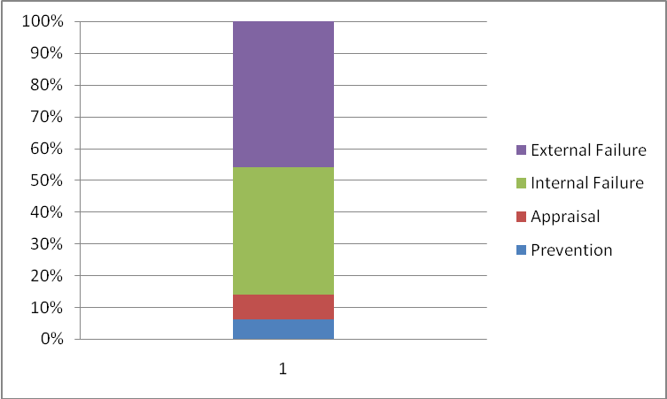
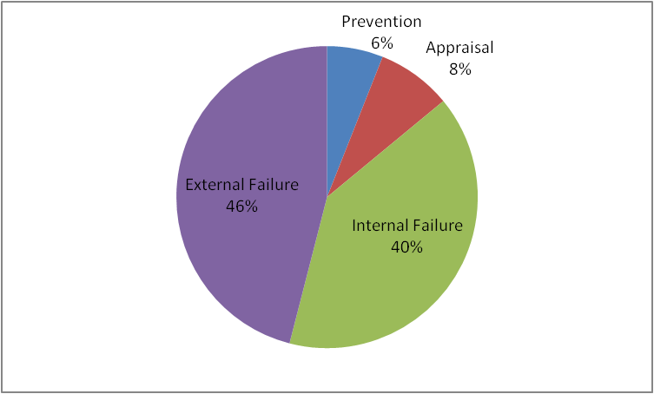

The graphs reveal that failure costs are approximately 86 percent of the total quality costs, suggesting that Evans needs to invest more in control activities to drive down failure costs.

3. The company has made good progress in reducing its quality costs, but still needs to invest more in prevention and control activities to reduce failure costs even more. Most companies that have achieved a practical zero-defect state will operate with quality costs between 2 and 3 percent of sales.
Cornerstone Exercise 14.2
1. Davis, Inc.
Interim Standard Performance Report: Quality Costs
For the Year Ended December 31, 2015

Actual Budgeted
Costs Costs Variance
Prevention costs:
Quality audits $ 90,000 $ 90,000ª $ 0
Vendor certification 180,000 180,000ª 0
Total prevention costs $ 270,000 $ 270,000 $ 0
Appraisal costs:
Product acceptance $ 135,000 $ 135,000ª $ 0
Process acceptance 109,500 112,500ª 3,000 F
Total appraisal costs $ 244,500 $ 247,500 $ 3,000 F
Internal failure costs:
Retesting $ 90,000 $ 81,600^{b} $ 8,400 U
Rework 180,000 172,800^{b} 7,200 U
Total internal failure costs $ 270,000 $ 254,400 $ 15,600 U
External failure costs:
Recalls $ 120,000 $ 120,000^{b} $ 0
Warranty 300,000 264,000^{b} 36,000 U
Total external failure costs $ 420,000 $ 384,000 $ 36,000 U
Total quality costs $1,204,500 $ 1,155,900 $ 48,600 U

Percentage of sales 10.04% 9.63% 0.41% U

ª2014 actual control cost × 1.50 (e.g., Quality audits = $90,000 × 1.50 =
$135,000)
^{b}2014 actual failure cost × 0.80 (e.g., Retesting = $102,000 × 0.8 = $81,600)

2. Davis has come very close to meeting the planned outcomes (only 0.41 percent short overall). Thus, management’s belief that investing an additional 50 percent in control costs would produce a 20 percent reduction in failure costs seems to be validated.

3. Rework would be expected to vary with sales. Thus, a 25 percent increase in sales, would cause a 25 percent increase in budgeted rework costs: $216,000 × 1.25 = $270,000. This would create a favorable rework variance of $90,000 ($180,000 – $270,000). All variable costs would have increased budgets, and the budgeted variance would be more favorable than initially calculated. Quality auditing is likely a discretionary fixed cost and so its budget would not be affected by changes in sales revenue.
Cornerstone Exercise 14.3
1.

The trend graph reveals that quality costs have been cut in half as a percentage of sales; however, at 12.5 percent, there is still substantial improvement opportunity left.

Cornerstone Exercise 14.3 (Continued)
2.

This graph reveals much more detail. For example, external failure costs are only about one-sixth of the original amount. Internal failure costs have decreased by about two-thirds. Clearly, the additional investment in control costs (which have significantly increased) has paid off.

Cornerstone Exercise 14.3 (Concluded)
3. Multiple-Period Trend Graph: Relative Quality Costs

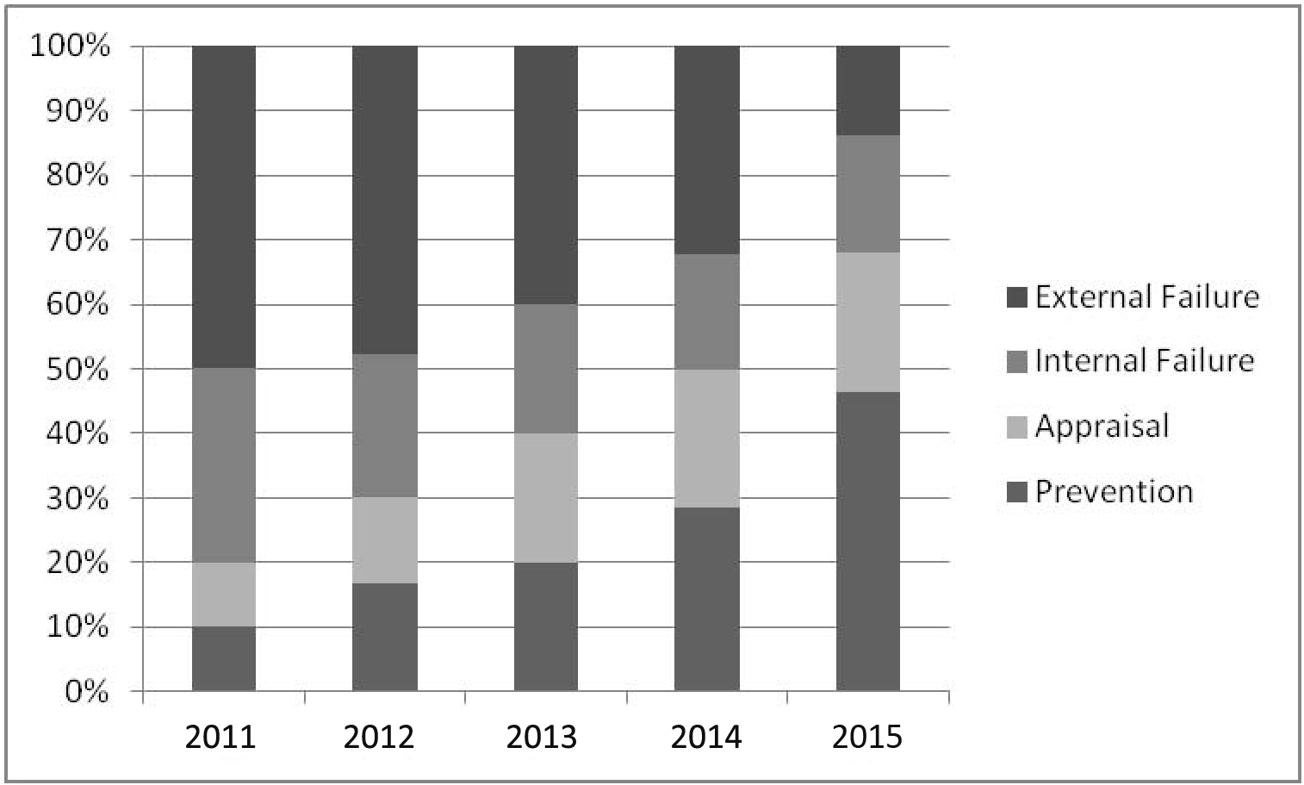

Failure costs have decreased from 80 percent of total costs to a little more than 30 percent, while control costs have gone from 20 percent to almost 70 percent. Thus, increasing control costs has driven down failure costs. Most companies operating in the near zero-defect state have control costs between 80 and 90 percent of total quality costs.

Cornerstone Exercise 14.4

1. Nabors Company
Long-Range Performance Report
For the Year Ended June 30, 2015

Actual Target
Costs Costs Variance
Prevention costs:
Prototype inspection $ 300,000 $375,000 $ 75,000 F
Vendor Certification 600,000 75,000 525,000 U
Total prevention costs $ 900,000 $450,000 $ 450,000 U
Appraisal costs:
Process acceptance $ 315,000 $ 50,000 $ 265,000 U
Test labor 360,000 0 360,000 U
Total appraisal costs $ 675,000 $ 50,000 $ 625,000 U
Internal failure costs:
Retesting $ 187,500 $ 0 $ 187,500 U
Rework 375,000 0 375,000 U
Total internal failure costs $ 562,500 $ 0 $ 562,500 U
External failure costs:
Recalls $ 243,750 $ 0 $ 243,750 U
Product liability 618,750 0 618,750 U
Total external failure costs $ 862,500 $ 0 $ 862,500 U
Total quality costs $3,000,000 $500,000 $2,500,000 U

Percentage of sales 12.0% 2% 10% U

Nabors is spending too much money on quality activities—especially failure and appraisal. More effort at improving quality is still needed.

2. Prevention costs are value-added costs and would be necessary to maintain the quality gains. The presence of appraisal costs may not be necessary in a strictly theoretical sense (if there are no defective units, then there is no need to engage in detection activities).
3. By spending less money on defects, Nabors can use the savings to expand and to employ additional people to support this expansion. Improved quality may naturally cause expansion by enhancing its competitive position. Thus, although improved quality may mean fewer jobs in some areas (such as inspection and rework), it also means that additional jobs will be created through expanded business activity.

Cornerstone Exercise 14.5
1. Verde Company
Environmental Cost Report
For the Year Ended December 31, 2015

Percentage
Environmental of Operating
Costs Costsª
Prevention costs:
Obtaining ISO 14001 certification $ 1,050,000
Designing processes 420,000 $ 1,470,000 2.94%
Detection costs:
Testing for contamination $ 700,000
Inspecting products 420,000 1,120,000 2.24
Internal failure costs:
Treating toxic waste $2,100,000
Maintaining pollution equipment 1,250,000 3,350,000 6.70
External failure costs:
Cleaning up oil spills $3,675,000
Cleaning up contaminated soil 5,775,000 9,450,000 18.90
Total quality costs $15,390,000 30.78%^{b}

ªActual operating costs of $50,000,000
^{b}$15,390,000/$50,000,000 = 30.78%
Environmental costs are 30.78 percent of total operating costs, seemingly a significant amount. Reducing environmental costs by improving environmental performance can significantly increase a firm’s profitability.

2. Relative Distribution: Environmental Costs
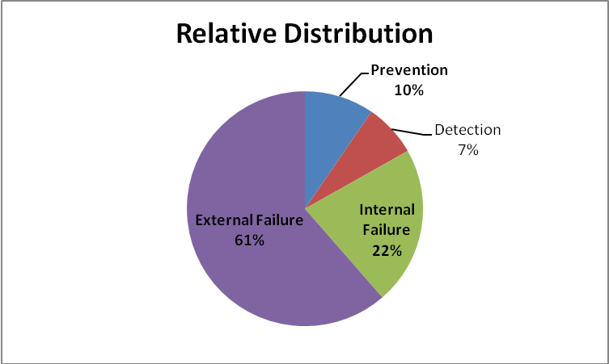

Cornerstone Exercise 14.5 (Concluded)
3. The most likely reason is that the cost is a social cost and not paid for by the company and thus not of direct interest to Verde. In fact, such formal recognition may create a potential liability for the company. The ethical nature of this issue is a difficult one. Several questions can be asked. Is the company consciously avoiding the reporting of unfavorable information? Is the company reporting all relevant information that could influence a user’s understanding of the reports? Is information being communicated fairly and objectively? Answers to these kinds of questions will help determine the
ethical content of the issue. Formal recognition is usually not required and so the company may simply be following a disclosure policy that generally is practiced by all reporting entities. This suggests that an unethical label is problematic.

Cornerstone Exercise 14.6
1. Rates:
Design products: $270,000/9,000 = $30 per design hour
Testing: $480,000/24,000 = $20 per test hour
Treating waste: $1,500,000/30,000 = $50 per pound of waste
Operating equipment: $1,200,000/120,000 = $10 per machine hour

2. Product costs:

Activities Solvent X Solvent Y

Design products ($30 × 6,000; $30 × 3,000) $ 180,000 $ 90,000
Test, contamination ($20 × 10,500; $20 × 13,500) 210,000 270,000
Treat toxic waste ($50 × 1,200; $50 × 28,800) 60,000 1,440,000
Operate equipment ($10 × 6,000; $10 × 114,000) 60,000 1,140,000
Total environmental cost $ 510,000 $ 2,940,000
Other manufacturing costs (nonenvironmental) 5,040,000 9,780,000
Total cost (environmental + other) $5,550,000 $ 12,720,000
Unit environmental cost* $ 0.85 $ 4.90
Unit cost (environmental + other)* $ 9.25 $ 21.20

*Cost divided by 600,000 units.

Cornerstone Exercise 14.6 (Concluded)
3. Using the associated activity rates of $30 per design hour ($360,000/12,000) and $50 per pound of waste ($750,000/15,000), the design cost assigned to Y increases by $90,000 ($90,000 to $180,000), and the toxic waste cost assigned to Y decreases by $727,500 ($1,440,000 to $712,500). The net decrease is $637,500 ($727,500 – $90,000), and the total environmental cost for Y decreases to $2,302,500 ($2,940,000 – $637,500); thus, the unit environmental cost for Solvent Y is now $3.84 ($2,302,500/600,000).

Exercises
Exercise 14.7
1. A quality product is one that meets or exceeds customer expectations relative to key quality attributes such as performance, aesthetics, reliability, durability, and fitness for use. A product is designed to display prespecified levels of each quality attribute. Customers expect the product to meet these specifications. Conformance is a measure of how well a product meets its specifications. Thus, a quality product is one that conforms to specifications.

2. Traditionally, a defective product has been defined as one that fails to conform to certain quality specifications. Usually, this meant that the product’s conformance was within an acceptable range of some ideal target value for the quality characteristic. Recent thinking argues that failure to conform to the target value of the quality characteristic can be very costly; thus, a defective product is one that fails to conform to the target value. In other words, the standard for nondefective is exact conformance to specifications. It is important to understand that poor quality is what costs, and as the percentage of conforming units increases, quality costs decrease. If, for example, quality costs are 15 percent of sales, it is conceivable that these costs could be reduced to 2 to 4 percent of sales, saving 11 to 13 percent. That is the gold mine to which the quality manager referred.

Exercise 14.8
1. Dental services should immediately convey the importance of aesthetics for service quality. Imagine walking into a dental office where the waiting area and service area are shabby and dirty and the dentist and assistants have an ill-kept appearance. This would not inspire much confidence in the quality of the dental services.

2. Responsiveness conveys the notion of being willing to help customers and provide prompt, consistent service. Assurance refers to the knowledge and courtesy of employees and their ability to convey trust and confidence. Empathy means providing caring, individualized attention to customers. Prompt, courteous service given by knowledgeable and caring providers clearly has a lot to do with service quality.
Exercise 14.9
1. Unit No. Actual Diameter y – T (y – T)² k(y – T)²
1 0.28 0.00 0.0000 $ 0.00
2 0.30 0.02 0.0004 12.00
3 0.26 –0.02 0.0004 12.00
4 0.27 –0.01 0.0001 3.00
0.0009 $27.00
Number of units ÷ 4 ÷ 4.00
Average 0.000225 $ 6.75

Thus, the average loss per unit is $6.75.

2. Hidden cost = $6.75 × 100,000 = $675,000

3. k(Measured costs) = Total external failure costs
k(Measured costs) = Measured costs + Hidden costs
(k – 1)(Measured costs) = Hidden costs
Measured costs = Hidden costs/(k – 1)
= $675,000/5
= $135,000

Measured costs are the costs that are observable and recorded in the accounting records. Hidden costs are opportunity costs resulting from poor quality and do not appear in the accounting records.

Exercise 14.10

1. Internal failure
2. Prevention
3. Internal failure
4. External failure
5. External failure
6. External failure
7. Prevention
8. Internal failure
9. Appraisal
10. Internal failure
11. External failure
12. Appraisal
13. Prevention
14. Prevention
15. External failure
16. Prevention
17. External failure
18. Prevention
19. Prevention
20. Appraisal
21. External failure
22. Prevention
23. Appraisal

Exercise 14.11
1. Activity rates:
Warranty: $816,000/2,550 = $320 per unit
Scrap: $612,000/4,250 = $144 per unit
Inspection: $306,000/5,100 = $60 per hour
Training: $85,000/170 = $500 per hour

Product cost:
Generator A Generator B
Warranty:
$320 × 1,700 $ 544,000
$320 × 850 $ 272,000
Scrap:
$144 × 3,400 489,600
$144 × 850 122,400
Inspection:
$60 × 3,400 204,000
$60 × 1,700 102,000
Training:
$500 × 85 42,500
$500 × 85 42,500
Total assigned $ 1,280,100 $ 538,900
Divided by units ÷ 170,000 ÷ 340,000
Unit cost $ 7.53* $ 1.59*

*Rounded.

Generator A has almost five times the amount of quality costs assigned than Generator B. Thus, A appears to be the lower-quality product.

2. The unit quality cost can be used to rank products in order of the lowest quality to that of the highest. This information can then be used to determine where quality improvement efforts should be focused. It may reveal, for example, that products follow the Pareto Principle: 20 percent of the products are causing 80 percent of the quality problems. (The Pareto Principle claims that 20 percent of the people do 80 percent of the work in any organization.)
Exercise 14.12

1. Kang Company
Quality Cost Report
For the Year Ended December 31, 2015

Percentage
Quality Costs of Sales
Prevention costs:
Design review $ 162,000
Quality training 54,000 $ 216,000 6.67%

Appraisal costs:
Materials inspection $ 21,600
Process acceptance 27,000
Product inspection 16,200 64,800 2.00

Internal failure costs:
Reinspection $ 27,000
Scrap 18,900 45,900 1.42

External failure costs:
Recalls $ 54,000
Lost sales 108,000
Returned goods 51,300 213,300 6.58
Total quality costs $ 540,000 16.67%
Exercise 14.12 (Concluded)
2.

Failure costs are almost 50 percent of the total costs. This indicates that there is still ample opportunity for improving quality by investing more in prevention and appraisal activities.

Exercise 14.13
1. Quality costs:
Year 1: $5,000,000 (0.25 × $20,000,000)
Year 2: $4,840,000 (0.22 × $22,000,000)
Year 3: $3,960,000 (0.18 × $22,000,000)
Year 4: $3,360,000 (0.14 × $24,000,000)

Net income increase:
Year 1: [(0.25 – 0.22) × $22,000,000] = $660,000
Year 2: [(0.22 – 0.18) × $22,000,000] = $880,000
Year 3: [(0.18 – 0.14) × $24,000,000] = $960,000

2. Profit potential: [(0.14 – 0.025) × $24,000,000] = $2,760,000

The 2.5 percent goal is the level many quality experts identify as the one that companies should strive to obtain. Gagnon Company’s experience shows that it is an achievable goal.

3. Year 3—No Change Year 3—Change
Sales $ 22,000,000 $ 22,000,000
Variable expenses 14,473,684ª 11,764,210^{b}
Contribution margin $ 7,526,316 $ 10,235,790

ª$250 × $22,000,000/$380
^{b}Quality costs per unit:
Year 1: 0.25 × $400 = $100.00
Year 3: 0.14 × $380 = $ 53.20
Decrease in per-unit variable quality cost = $100.00 – $53.20 = $46.80
Decrease in per-unit total variable cost = $250.00 – $46.80 = $203.20
Variable costs (total, Year 3) = $203.20 × ($22,000,000/$380) = $11,764,210.

Increase in profitability:
$10,235,790 – $7,526,316 = $2,709,474
Exercise 14.14
1. 2011: $15,000,000/$60,000,000 = 0.25
2015: $1,875,000/$75,000,000 = 0.025

The quality cost-to-sales ratio improved from 25 percent to 2.5 percent. The 2.5 percent ratio is achievable as evidenced by the experiences of real-world corporations (e.g., Tennant Company).

2. Internal failure: $4,500,000/$15,000,000 = 30%
External failure: $6,000,000/$15,000,000 = 40%
Appraisal: $2,700,000/$15,000,000 = 18%
Prevention: $1,800,000/$15,000,000 = 12%

The pie chart for 2011 is as follows:

The percentage of quality costs spent on internal and external failures is too high. If costs are reduced to 2.5 percent, then the company is approaching the goal of zero defects. As zero defects is approached, failure costs will approach zero, leaving the bulk of quality costs in the prevention and appraisal categories. Of these two categories, the prevention category would dominate.

Exercise 14.14 (Continued)
3. Internal failure: $225,000/$1,875,000 = 12%
External failure: $150,000/$1,875,000 = 8%
Appraisal: $562,500/$1,875,000 = 30%
Prevention: $937,500/$1,875,000 = 50%

The pie chart for 2015 is as follows:

Quality costs are better distributed than in 2011. Control costs account for 80 percent of the total quality costs (versus only 30 percent in 2011). Failure costs have shrunk from 70 percent of the total in 2011 to only 20 percent in 2015. Moreover, total quality costs have shrunk from 25 percent of sales to 2.5 percent of sales. Costs in every category have been reduced. From an
activity-based management perspective, further reductions are possible—at least in the failure categories. These are non-value-added costs and, in theory, can and should be reduced to zero.

4. Some external failure costs are not measured and reported in the accounting records. If the multiplier effect were four (for example), then in 2015, the external failure costs would be $450,000 [(4 × $150,000) – $150,000] higher than reported. Given the reality of hidden costs, there is some validity to this point of view and it may be wise to invest additional funds for control activities.

Exercise 14.14 (Concluded)
5. Gainsharing provides a strong incentive for managers to improve quality and reduce quality costs. Gainsharing is a good idea, provided the incentive system is carefully designed. The bonus must be truly based on quality improvements. Quality gains, stemming from quality cost reductions, must flow from true quality improvements. Thus, there should be operational quality measures that provide evidence of actual quality improvements. One possibility is to base bonuses only on reductions in failure and appraisal categories. This provides an incentive for managers to invest in preventive activities—actions that should reduce “poor” quality costs.

Exercise 14.15
1. Only four of the activities should be implemented: quality training, process control, supplier evaluation, and engineering redesign. Each of these four activities reduces failure costs more than it costs to implement the activity (thus, increasing the bonus pool). The cost reduction for failures is less than the amount spent for product inspection and prototype testing.

Total quality costs:
Current quality control $ 160,000
Quality training 160,000
Process control 200,000
Supplier evaluation 120,000
Engineering redesign 40,000
Failure costs 184,000*
$ 864,000

*$40,000 + ($720,000 – $656,000) + ($200,000 – $120,000) = $184,000 (adds back cost reductions of two activities not implemented)
Exercise 14.15 (Concluded)
2. a. Total quality costs were reduced by $736,000 ($1,600,000 – $864,000). Quality training increased costs by $160,000 but reduced failure costs by $400,000, for a net gain of $240,000. Process control increased costs by $200,000 but decreased failure costs by $320,000, for a net gain of $120,000. Supplier evaluation increased costs by $120,000 but decreased failure costs by $456,000, for a net gain of $336,000. Engineering redesign increased costs by $40,000 but decreased failure costs by $80,000, for a net gain of $40,000.

Total net gain:
Quality training $240,000
Process control 120,000
Supplier evaluation 336,000
Engineering redesign 40,000
$736,000

b. Distribution percentage:
Control costs:* $680,000/$864,000 = 79% (rounded)
Failure costs: $184,000/$864,000 = 21% (rounded)

*Total control costs less costs of activities not implemented:
$1,000,000 – $80,000 – $240,000 = $680,000
Failure costs = $864,000 – $680,000

c. Bonus pool = 0.10 × $736,000 = $73,600

3. All of the same activities would be adopted plus prototype testing. Of the activities adopted, quality training, supplier evaluation, engineering redesign, and prototype testing are all prevention activities and so would not be counted in the cost reduction calculation. Failure costs would now be $104,000 (prototype addition reduces failure costs by an additional $80,000). The initial failure and appraisal costs are $1,600,000 ($1,440,000 + $160,000). The ending failure and appraisal costs are the sum of the current appraisal costs, ending failure costs, and the cost of adding process control: $160,000 + $104,000 + $200,000 = $464,000. Thus, the cost reductions counted for the bonus pool would be $1,136,000 ($1,600,000 – $464,000), and the bonus would be $113,600 (0.10 × $1,136,000). This approach has some merit as it encourages managers to invest in value-added activities and avoid the temptation of reducing prevention costs prematurely. It is possible, however, that some prevention activities are not really worth doing, and this approach may lead to an overinvestment in this category.
Exercise 14.16
1. Quality costs, 2014 $110,000
Less quality costs, 2015 81,000
$ 29,000

2. Tru-Delite Frozen Desserts, Inc.
Long-Range Performance Report
For the Year Ended December 31, 2015

Actual Costs* Long-Range
2015 Target Costs Variance
Prevention costs:
Training program $ 6,000 $ 3,750 $ 2,250 U
Supplier evaluation 13,000 4,688 8,312 U
Total prevention costs $19,000 $ 8,438 $ 10,562 U
Appraisal costs:
Test labor $10,000 $ 4,687** $ 5,313 U
Inspection labor 30,000 2,813 27,187 U
Total appraisal costs $40,000 $ 7,500 $ 32,500 U
Internal failure costs:
Scrap $18,750 $ 2,812** $ 15,938 U
Rework 12,500 0 12,500 U
Total internal failure costs $31,250 $ 2,812 $ 28,438 U
External failure costs:
Consumer complaints $ 6,250 $ 0 $ 6,250 U
Lost sales, incorrect labeling 0 0 0
Total external failure costs $ 6,250 $ 0 $ 6,250 U
Total quality costs $96,500 $18,750 $ 77,750 U

Percentage of sales 12.9% 2.5% 10.4% U

*Adjusted for sales of $750,000 [Uses the actual variable cost ratios of 2015 to compute the “actual” unit-level variable costs for this level of activity; prevention costs are discretionary fixed and so are assumed to not change as sales increase; all other costs are assumed to vary with sales volume and so are adjusted to the $750,000 level; for example, test labor is ($8,000/ $600,000) × $750,000 = $10,000].
**Rounded down so quality costs are 2.5% of sales.
Exercise 14.16 (Concluded)
3. Prevention and some appraisal costs can be interpreted as value-added costs. All failure costs are non-value-added. Thus, the distribution of costs for 2019 cannot all be value-added (there are non-zero internal failure costs). If they were, then the variances would be the non-value-added costs being incurred in 2015.

4. There would be a $77,750 increase in profits in 2019 if total quality costs are 2.5 percent of sales and the targeted distribution is achieved (the $77,750 increase is the savings reported in the long-range performance report in Requirement 2).

Exercise 14.17
1. Multiple-Period Trend Graph: Total Quality Costs

There has been a steady downward trend in quality costs expressed as a percentage of sales. Overall, the percentage has decreased from 25 to 12 percent, a significant improvement.
Exercise 14.17 (Continued)

2. There have been significant reductions in internal and external failure costs. Prevention costs increased; appraisal costs remained the same. The graph reveals the trend for each category of costs and how management is changing the expenditure pattern for each category. In 2011, a greater percentage of sales was spent on external and internal failure costs than for appraisal and prevention costs. By 2015, the amount spent on internal and external failures is less than the amount spent on appraisal and prevention. The strategy of shifting more resources to appraisal and prevention seems to have worked since total quality costs have dropped from 25 to 12 percent.
Exercise 14.17 (Concluded)

3. The graph above reveals a favorable trend in the relative distribution. Failure and control costs have gone from an 80:20 mix to a 25:75 mix.
Exercise 14.18
1. Ecoefficiency means that more competitively priced goods and services can be produced while simultaneously reducing negative environmental impacts. Thus, ecological and economic performance can and should be complementary. Several factors support this view. First, evidence exists that environmental costs can be reduced as environmental performance improves. Second, environmentally responsible firms tend to capture external benefits such as lower cost of capital and lower insurance rates. Third, improving
environmental performance produces significant social benefits, improves a company’s image and external relations, and thus enhances the ability to sell products and services. Fourth, improving environmental performance
awakens within managers a need to innovate and develop new products and markets. All of this together should produce better environmental performance than that of compliance management.

2. The guided ecoefficiency view requires that regulatory intervention specify only the desired pollution reductions without specifying how these reductions are to be achieved. Several key assumptions underlie guided ecoefficiency. First, pollution is a form of economic inefficiency. Second, regulatory intervention that requires a reduction in pollution will stimulate innovation to bring about the reduction while simultaneously improving economic efficiency. Third, regulatory intervention is required because managers have bounded rationality—they will likely not recognize that pollution can be reduced without the outside stimulus.

Exercise 14.19
1. Sustainable development meets the needs of the present without compromising the ability of future generations to meet their needs. It considers the needs of growing populations, the need to have human prosperity and equity, and the need to conserve and pass economic resources on to future generations.

2. Ecoefficiency is a critical breakthrough because it establishes a link between economic activity and environmental impacts. Most environmental problems can be solved by the firms themselves simply because improving environmental performance improves economic efficiency. Improving economic efficiency reduces the demands by the current generation, preserving resources for future generations.

Exercise 14.19 (Concluded)
3. Possible reasons include the following: (1) the ecoefficiency paradigm is not valid; (2) many managers still are holding hard and fast to the traditional view: improving environmental performance and economic efficiency are incompatible objectives; (3) the ecoefficiency paradigm is not widely known; (4) managers are not fully rational; and (5) managers are satisficers and not maximizers—that is, the profits being earned are sufficient without undertaking any additional profit-increasing projects. Increasing the number of participants in ecoefficiency may require the development of empirical evidence that is stronger than anecdotal cases of successes. It may also require regulatory intervention of the type required by the guided ecoefficiency paradigm.

Exercise 14.20

1. Prevention (SD)
2. Prevention (SD)
3. Internal failure (SD)
4. External failure (societal)
5. Detection (SD)
6. Prevention (SD)
7. Internal failure
8. External failure (societal)
9. Detection (SD)
10. External failure (societal)
11. Prevention (SD)
12. External failure (private)
13. Internal failure (SD)
14. Detection (SD)
15. Internal failure
16. Detection (SD)

Exercise 14.21
1. Bing Pharmaceuticals
Environmental Cost Report
For the Year Ended December 31, 2015

Percentage
of Operating
Environmental Costs Costsª
Prevention costs:
Evaluating/selecting suppliers $ 300,000
Recycling products 187,500 $ 487,500 0.33%
Detection costs:
Inspecting products/processes $ 1,500,000
Developing perf. measures 150,000 1,650,000 1.10
Internal failure costs:
Treating/disposing toxic waste $12,000,000
Operating equipment 2,100,000
Licensing facilities 900,000 15,000,000 10.00
External failure costs:
Settling claims $ 3,000,000
Cleanup of soil 4,500,000 7,500,000 5.00
Total quality costs $ 24,637,500 16.43%^{b}

ªActual operating costs of $150,000,000
^{b}$14,637,500/$150,000,000 = 16.43%

2.

This distribution reveals that the company is paying little attention to preventing and detecting environmental costs. To improve environmental performance, much more needs to be invested in the prevention and detectioncategories.
Exercise 14.22
1. Both items should be added to the external failure costs category in the report. The first item would add $1,312,500 and is a private cost. The second adds $3,000,000 and is a societal cost. Under a full costing regime, the $3,000,000 should also be included in the report. Often, however, only private costs will be included.

2. Bing caused the opportunity cost, and many would argue that it should be disclosed. Whether it will voluntarily disclose this cost is questionable. Management would likely feel that such disclosure would draw unfavorable attention to the company and damage its image.

Perhaps if the disclosure is coupled with an announcement of the cleanup of the river and lake, then it could be turned to the advantage of the company: “We are undertaking a cleanup, and one of the major benefits to the community is the restoration of the fishing and recreational opportunities worth $3,000,000 to the community.”

Exercise 14.23
1. Activity rates:
Packaging materials: $3,375,000/3,375,000 = $1.00 per pound
Energy usage: $900,000/1,125,000 = $0.80 per kilowatt-hour
Toxin releases: $450,000/2,250,000 = $0.20 per pound
Pollution control: $1,050,000/375,000 = $2.80 per machine hour

Unit cost:
Org AB Org XY
Packaging materials:
$1.00 × 2,250,000 $ 2,250,000
$1.00 × 1,125,000 $ 1,125,000
Energy usage:
$0.80 × 750,000 600,000
$0.80 × 375,000 300,000
Toxin releases:
$0.20 × 1,875,000 375,000
$0.20 × 375,000 75,000
Pollution control:
$2.80 × 300,000 840,000
$2.80 × 75,000 210,000
Total assigned $ 4,065,000 $ 1,710,000
Divided by units ÷ 7,500,000 ÷ 18,750,000
Unit cost per pound $ 0.542 $ 0.0912
Exercise 14.23 (Concluded)
Org AB has the highest environmental cost per unit. So, to the extent that the per-unit environmental cost measures environmental damage, we can say that this product causes more problems.

2. Excessive use of materials and energy is classified as an external failure cost. (Once too much is used, then the customers and society bear the cost—the effect has been “released” into the environment.)

3. These costs would increase the toxin release rate by $0.90 per pound ($2,025,000/2,250,000). This increase, in turn, would increase the amount
assigned to each product: $1,687,500 to the Org AB product and $337,500 to the Org XY product. Unit costs, then, would increase by $0.225 for the Org AB product ($1,687,500/7,500,000) and $0.018 for the Org XY product ($337,500/18,750,000). This is a full costing approach, which many feel ought to be the way environmental costs are assigned. However, it is often difficult to estimate the societal costs, and many firms restrict their cost assignments to private costs.

Exercise 14.24
1. New activity rates:
Packaging materials: $1,518,750/3,037,500 = $0.50 per pound
Energy usage: $600,000/750,000 = $0.80 per kilowatt-hour
Toxin releases: $112,500/1,125,000 = $0.10 per pound
Pollution control: $1,050,000/375,000 = $2.80 per machine hour
Engineering: $450,000/15,000 = $30 per engineering hour
Treatment: $303,750/3,037,500 = $0.10 per pound

Note: Since pounds of packaging is the driver for both packaging and packaging treatment, the rates could be combined, yielding a packaging and treatment rate of $0.60 per pound. The 3,037,500 pounds used for the rate is 3,375,000 less 10% of the original 3,375,000 pounds.
Exercise 14.24 (Continued)
Unit cost:
Org AB Org XY
Packaging materials and treatment:
$0.60 × 2,025,000 $ 1,215,000
$0.60 × 1,012,500 $ 607,500
Energy usage:
$0.80 × 500,000 400,000
$0.80 × 250,000 200,000
Toxic releases:
$0.10 × 937,500 93,750
$0.10 × 187,500 18,750
Pollution control:
$2.80 × 300,000 840,000
$2.80 × 75,000 210,000
Engineering:
$30 × 11,250 337,500
$30 × 3,750 112,500
Total assigned $ 2,886,250 $ 1,148,750
Divided by units ÷ 7,500,000 ÷ 18,750,000
Unit cost per pound $ 0.3848* $ 0.0613*

*Rounded.

2. Savings:
Org AB Org XY Total
Before^{b} $ 4,065,000 $ 1,710,000 $ 5,775,000
After 2,886,250 1,148,750 4,035,000
Total savings $ 1,178,750 $ 561,250 $ 1,740,000
Pounds ÷ 7,500,000 ÷ 18,750,000
Unit savings $ 0.1572ª $ 0.0299ª

ª Rounded.
^{b}See the solution to Exercise 14–23.

This illustrates that improving environmental performance can improve economic efficiency, which is consistent with the claims of ecoefficiency.

3. Excessive energy and materials usage and releasing toxins are external failure activities; operating pollution control equipment is an internal failure activity. Engineering is a prevention activity (added during the improvement process).
Exercise 14.24 (Concluded)
4. The environmental improvements have reduced total and per-unit operating costs for each product. This now makes price reductions possible, reducing customer sacrifice, and potentially creating a competitive advantage. The reduced environmental damage may also enhance product and company images, with the potential of attracting more customers. Other possible benefits that may contribute to a competitive advantage include a lower cost of capital and lower insurance costs.

CPA-TYPE EXERCISES
Exercise 14.25
a. Reworking a unit is an internal failure cost and so its subsequent inspection is also an internal failure cost. The next two choices are external failure as they are activities that occur after the product is in the hands of the customer. The last choice is clearly a prevention activity.
Exercise 14.26
d. Hidden costs are opportunity costs resulting from poor quality. Hidden costs are not recorded in the company’s accounting records. Lost market share is the only answer fitting this definition.
Exercise 14.27
b. The Taguchi loss function is used to estimate hidden costs of external failure.
Exercise 14.28
c. External failure costs are incurred when pollution is released into the environment and are of two types: Realized and unrealized. Realized cost are paid for by the firm; unrealized costs are paid for by society and are called societal costs.
Exercise 14.29
d. Product B is the “dirtier” product as it is costing $40 per unit for environmental costs and Product A is costing only $8 per unit. The consumption ratios for Product B are 1/3 and 1/5, yielding activity costs assigned to B of $40,000 and $80,000 for a total of $120,000 (implying that $400,000 are assigned to Product A). The unit environmental cost for Product A is $400,000/50,000 = $8 per unit; the unit environmental cost for Product B is $120,000/3,000 = $40 per unit—five times more. Product B is clearly the dirtier product.

problems
Problem 14.30
1. Shorts Company
Quality Cost Report
For the Year Ended December 31, 2015

Percentage
Quality Costs of Sales
Prevention costs:
Vendor certification $ 720,000
Design reviews 180,000 $ 900,000 1.5%
Appraisal costs:
Test labor $1,800,000
Inspection labor 1,500,000 3,300,000 5.5
Internal failure costs:
Retesting $1,800,000
Rework 2,400,000 4,200,000 7.0
External failure costs:
Consumer complaints $ 1,200,000
Warranty 2,400,000 3,600,000 6.0
Total quality costs $12,000,000 20.0%

2. Relative Percentage
Prevention 7.5% (1.5/20)
Appraisal 27.5 (5.5/20)
Internal failure 35.0 (7.0/20)
External failure 30.0 (6.0/20)

Failure costs account for 65 percent of the total quality costs. This implies that more resources need to be invested in the control activities with the objective of driving down failure costs.

3. Hidden costs = $15 × 600,000 = $9,000,000. External failure costs increase to $12,600,000 and total quality costs to $21,000,000. Now, external failure costs are 60 percent of total quality costs, and failure costs are 80 percent of total quality costs. This is a serious imbalance between control and failure costs, signaling a significant opportunity to increase profits by decreasing failure costs.
Problem 14.30 (Concluded)
4. There is some validity in the quality manager’s observation. Increasing control costs will likely decrease hidden failure costs as well as measured costs. However, ignoring the hidden costs may result in underestimating the action needed to reduce failure costs. The company could under invest in control activities and produce a suboptimal outcome. Approximating external failure costs is useful because it serves as an attention-getting signal. Management may become much more serious about improving quality once it realizes the full potential for increasing profits.

Problem 14.31
1. k = c/d² = $20/25 = $0.80

Unit No. Actual Weight y – T (y – T)² k(y – T)²
1 100 0 0 0
2 105 5 25 20
3 110 10 100 80
4 90 –10 100 80
5 85 –15 225 180
450 $ 360
Number of units ÷ 5 ÷ 5
Average 90 $ 72

2. Hidden cost = $72 × 100,000 = $7,200,000

3. The consumer would value greater durability; therefore, there is no loss expected from exceeding the target. This creates a need for an asymmetric loss function. Using the lower left half of the quadratic loss function is one example of an asymmetric loss function. The k value is computed as follows:

k = c/d² = $750/1,000,000 = $0.00075

And the predicted loss for each of the three lives:

Unit No. Actual Durability y – T (y – T)² k(y – T)²
1 6,500 13,500 182,250,000 $136,688*
2 11,000 9,000 81,000,000 60,750
3 15,500 4,500 20,250,000 15,188*

*Rounded.

This reveals that durability is extremely important and that downward deviations can be extremely costly.
Problem 14.32
1. Lost contribution margin = $8 × 100,000 = $800,000, or $200,000 per quarter

Sales revenue/Quarter = $92 × 25,000 = $2,300,000

Percent of sales needed to regain lost contribution margin:
$200,000/$2,300,000 = 8.7%

At 1 percent gain per quarter, 8.7 quarters, or a little over two years, would be needed to regain former profitability.

2. At the end of three years, quality costs will be 4 percent of sales, a reduction equal to 12 percent of sales.

Savings = 0.12 × ($92 × 100,000) = $1,104,000
Increase in unit contribution margin = $1,104,000/100,000 = $11.04

Projected unit CM = $11.04 + ($92 – $90) = $13.04
Projected total CM at $92 price = $13.04 × 100,000 = $1,304,000

Price decreases:
$1.00: Total CM = $12.04 × 110,000 = $1,324,400
$2.00: Total CM = $11.04 × 120,000 = $1,324,800
$3.00: Total CM = $10.04 × 130,000 = $1,305,200

Recommended decrease is from $92 to $90.

Increase in contribution margin:
$ 1,324,800
(1,304,000)
$ 20,800
Problem 14.32 (Concluded)
3. To find the point where the price should first be reduced, we need to find the point where total contribution margin remains unchanged. Let X = CM/Unit.

Current CM = 100,000X
New CM = 110,000(X – $1)

100,000X = 110,000(X – $1)
10,000X = $110,000
X = $11

When the unit CM is greater than $11, the price should be reduced by $1.00. To find this point in time:

Current CM = $92 – $90 = $2
Gain needed = $11 – $2 = $9

Annual CM needed = ($9 × 100,000) = $900,000
Quarterly CM needed = $900,000/4 = $225,000
Quarterly percent of sales needed = $225,000/$2,300,000 = 9.8%

At 1 percent per quarter, it will take 9.8 quarters to gain $9 per unit. Thus, after 9.8 quarters, the price can decrease by $1.

4. The difference is long-run versus short-run thinking. The marketing manager had a strategic orientation. We can see the value of cost information, particularly quality cost information, in strategic decision making. In fact, the emphasis on total quality control and the identification of specific quality costs drove the decision. Once the decision was made, the need to reduce the costs as planned is critical, emphasizing the importance of a quality cost control program. Interim and longer-range reports would be quite useful in controlling quality costs.
Problem 14.33

1. Prevention, fixed
2. Internal failure, variable
3. External failure, variable
4. External failure, variable
5. Internal failure, variable
6. Appraisal, fixed
7. Prevention, fixed
8. Appraisal, variable
9. Prevention, fixed
10. Internal failure, variable
11. External failure, variable
12. Appraisal, fixed
13. Internal failure, variable
14. Internal failure, variable
15. Prevention, fixed
16. Appraisal, variable
17. Internal failure, variable
18. Appraisal, variable
19. Prevention, fixed
20. Prevention, fixed

Problem 14.34
1. Banshee Company
Quality Cost Report
For the Year Ended 2015

Percentage
Quality Costs of Sales
Prevention costs:
Quality training $ 30,000 0.2%
Appraisal costs:
Product acceptance $ 240,000 1.6
Internal failure costs:
Scrap $ 450,000
Rework 270,000
$ 720,000 4.8
External failure costs:
Repair $ 90,000
Order cancellation 150,000
Customer complaints 121,500
Sales allowance 45,000
$ 406,500 2.7
Total quality costs $1,396,500 9.3%
Problem 14.34 (Continued)
2. Profits: $1,500,000
Quality costs: $1,396,500
Quality costs/Sales = 9.3%
Quality costs/Profits = 93%

Wayne should be concerned as the quality cost-sales ratio is 9.3%, and the quality costs are almost as large as income. Although the ratio is lower than the 20 to 30 percent range that many companies apparently have, there is still ample opportunity for improvement.

3. Prevention: $30,000/$1,396,500 = 2.1%
Appraisal: $240,000/$1,396,500 = 17.2%
Internal failure: $720,000/$1,396,500 = 51.6%
External failure: $406,500/$1,396,500 = 29.1%

The pie chart is as follows:

Too much is spent on failure costs. These costs are non-value-added costs and should eventually be eliminated. Prevention and appraisal activities should be given much more emphasis. If anything, experiences of real-world companies (e.g., Tennant Company and Westinghouse Electric) indicate that the control costs should be 80 percent and the failure costs 20 percent. The distribution of quality costs needs to be reversed!
Problem 14.34 (Concluded)
4. The company should increase prevention and appraisal costs. The additional amounts spent on these programs will be recouped with additional savings from a resulting decrease in failure costs.

5. Quality costs: $15,000,000 × 2.5% = $375,000
Profits would increase by $1,021,500 ($1,396,500 – $375,000).

Problem 14.35
1. January February
Prevention costs:
Quality planning (F) $ 2,000 $ 2,000
New product review (F) 500 500
Quality training (F) 1,000 1,000
Total prevention costs $ 3,500 $ 3,500
Appraisal costs:
Materials inspection (F) $ 2,500 $ 2,500
Product acceptance (V) 13,000 15,000
Field inspection (V) 12,000 14,000
Total appraisal costs $ 27,500 $ 31,500
Internal failure costs:
Scrap (V) $ 10,000 $ 12,000
Retesting (V) 6,000 7,200
Rework (V) 9,000 10,800
Downtime (V) 5,000 6,000
Total internal failure costs $ 30,000 $ 36,000
External failure costs:
Warranty (V) $ 15,000 $ 18,000
Allowances (V) 7,500 9,000
Complaint adjustment (F) 2,500 2,500
Total external failure costs $ 25,000 $ 29,500
Total quality costs $ 86,000 $ 100,500
Problem 14.35 (Concluded)
2. Actual Budgeted
Costs Costs* Variance
Prevention costs:
Quality planning (F) $ 2,500 $ 2,000 $ 500 U
New product review (F) 700 500 200 U
Quality training (F) 1,000 1,000 0
Total prevention costs $ 4,200 $ 3,500 $ 700 U
Appraisal costs:
Materials inspection (F) $ 2,500 $ 2,500 $ 0
Product acceptance (V) 14,000 14,300 300 F
Field inspection (V) 14,000 13,200 800 U
Total appraisal costs $ 30,500 $ 30,000 $ 500 U
Internal failure costs:
Scrap (V) $ 12,500 $ 11,000 $1,500 U
Retesting (V) 7,000 6,600 400 U
Rework (V) 11,000 9,900 1,100 U
Downtime (V) 5,500 5,500 0
Total internal failure costs $ 36,000 $ 33,000 $ 3,000 U
External failure costs:
Warranty (V) $ 17,500 $ 16,500 $ 1,000 U
Allowances (V) 8,500 8,250 250 U
Complaint adjustment (F) 2,500 2,500 0
Total external failure costs $ 28,500 $ 27,250 $ 1,250 U
Total quality costs $ 99,200 $ 93,750 $ 5,450 U

*Budgeted costs need to be adjusted to reflect actual sales of $550,000. Fixed costs don’t change with sales. However, variable costs do, and so the bud-geted variable cost ratio can be used to make the adjustment. For example, the adjusted budget for scrap is ($10,000/$500,000) × $550,000 = $11,000.

For January, quality costs were 18 percent of sales ($99,200/$550,000). This is higher than the budgeted amount of 17 percent, but lower than previous
periods.
Problem 14.36
1. 2014
Appraisal: $360,000/$2,048,000 = 17.6%
Prevention: $8,000/$2,048,000 = 0.4%
Internal failure: $1,000,000/$2,048,000 = 48.8%
External failure: $680,000/$2,048,000 = 33.2%

The pie chart for 2014 is as follows:

Problem 14.36 (Continued)
2015
Appraisal: $328,000/$2,048,000 = 16.0%
Prevention: $160,000/$2,048,000 = 7.8%
Internal failure: $820,000/$2,048,000 = 40.0%
External failure: $740,000/$2,048,000 = 36.1%

The pie chart for 2015 is as follows:

Yes. More effort is clearly needed for prevention and appraisal activities. The movement is in that direction, and total failure costs have declined.
Problem 14.36 (Concluded)
2. Major Company
Performance Report: Quality Costs
One-Year Trend
For the Year Ended December 31, 2015

Actual Costs Actual Costs*
2015 2014 Variance
Prevention costs:
Quality circles $ 40,000 $ 4,000 $ 36,000 U
Design reviews 20,000 2,000 18,000 U
Improvement projects 100,000 2,000 98,000 U
Total prevention costs $ 160,000 $ 8,000 $152,000 U
Appraisal costs:
Packaging inspection $ 300,000 $ 400,000 $100,000 F
Product acceptance 28,000 50,000 22,000 F
Total appraisal costs $ 328,000 $ 450,000 $122,000 F
Internal failure costs:
Scrap $ 240,000 $ 350,000 $110,000 F
Rework 320,000 450,000 130,000 F
Yield losses 100,000 200,000 100,000 F
Retesting 160,000 250,000 90,000 F
Total internal failure costs $ 820,000 $1,250,000 $430,000 F
External failure costs:
Returned materials $ 160,000 $ 200,000 $ 40,000 F
Allowances 140,000 150,000 10,000 F
Warranty 440,000 500,000 60,000 F
Total external failure costs $ 740,000 $ 850,000 $110,000 F
Total quality costs $2,048,000 $2,558,000 $510,000 F

*To compare 2015 costs with 2014 costs, the costs for 2014 must be adjusted to a sales level of $10,000,000. Thus, all variable costs will change from the 2014 levels. For example, the adjusted product packaging inspection cost is ($320,000/$8,000,000) × $10,000,000 = $400,000.

Profits increased by $510,000.

3. $2,048,000 – ($10,000,000 × 2.5%) = $1,798,000
Problem 14.37
1. Paper
Diapers Napkins Towels Total
Prevention 0.9% 1.00% 1.63% 1.08%
Appraisal 0.8 1.17 1.63 1.08
Internal failure 1.8 1.08 1.63 1.55
External failure 1.5 0.75 1.63 1.30
Total 5.0% 4.00% 6.52% 5.01%

The company has achieved its goal as no more than 5 percent of sales was spent on quality (in total). Looking at individual products, the best outcome (napkins) seems to be where appraisal and prevention costs exceed failure costs. If this distribution is better, the total suggests that more should be spent on prevention and appraisal. Opportunities to do so are present in the diaper and paper towel lines.

2. Paper
Diapers Napkins Towels Total
Prevention 1.8% 2.00% 3.25% 2.15%
Appraisal 1.6 2.33 3.25 2.15
Internal failure 3.6 2.17 3.25 3.10
External failure 3.0 1.50 3.25 2.60
Total 10.0% 8.00% 13.00% 10.00%

For this scenario, the goal of 5 percent is far from being reached. If the idea of balancing costs by category is true, then further reductions can be achieved by shifting more resources into prevention and appraisal activities. Of the three lines, the diaper line is particularly one where more resources should be spent on prevention and appraisal activities. Shifting more resources into these two categories has the potential to reduce the percentage for each line to 5 percent or below.

Shifting more resources into prevention for paper towels and napkins would not create balanced categories. It appears difficult to achieve the overall 5 percent goal by balancing category costs. The preceding results suggest that the even distribution suggestion of the divisional manager may not be the optimal combination. Perhaps even more emphasis should be placed on control costs.
Problem 14.37 (Concluded)
3. Paper
Diapers Napkins Towels Total
Prevention 1.80% 3.33% 2.03% 2.15%
Appraisal 1.60 3.89 2.03 2.15
Internal failure 3.60 3.61 2.03 3.10
External failure 3.00 2.50 2.03 2.60
Total 10.00% 13.33% 8.12% 10.00%

Again, more should be spent on prevention and appraisal activities. However, the lines on which to concentrate these resources are now the diaper lines.

4. If quality costs are reported by segment, a manager will know where to concentrate efforts for cost reduction.

Problem 14.38
1. Internal External
Prevention Appraisal Failure Failure Total
2011 1.00% 2.00% 16.00% 12.00% 31.00%
2012 4.17 2.50 10.00 8.33 25.00
2013 5.00 4.29 5.00 3.57 17.86
2014 6.67 2.50 4.17 3.33 16.67
2015 10.00 1.00 2.40 1.60 15.00

Problem 14.38 (Continued)
2.

Problem 14.38 (Concluded)

Yes, quality costs overall have dropped from 31 percent of sales to 15 percent of sales, a significant improvement. Real evidence for quality improvement stems from the fact that internal failure costs have gone from 16 percent to 2.4 percent, external failure costs from 12 percent to 1.6 percent, and appraisal costs from 2 percent to 1 percent. This reduction of failure costs has been achieved by putting more resources into prevention (from 1 percent to 10 percent).

3. Quality costs at the 2011 rates:

Internal External
Prevention Appraisal Failure Failure Total
2014 $6,000 $12,000 $96,000 $72,000 $186,000
2015 5,000 10,000 80,000 60,000 155,000

Profit increase (2014): $186,000 – $100,000 = $86,000
Profit increase (2015): $155,000 – $75,000 = $80,000
Problem 14.39
1. Iona Company
Interim Performance Report: Quality Costs
For the Year Ended December 31, 2015

Actual Costs Budgeted Costs Variance
Prevention costs:
Fixed:
Quality planning $ 150,000 $ 150,000 $ 0
Quality training 20,000 20,000 0
Quality improvement 100,000 80,000 20,000 U
Quality reporting 12,000 10,000 2,000 U
Total prevention costs $ 282,000 $ 260,000 $ 22,000 U
Appraisal costs:
Variable:
Proofreading $ 520,000 $ 500,000 $ 20,000 U
Other inspection 60,000 50,000 10,000 U
Total appraisal costs $ 580,000 $ 550,000 $ 30,000 U
Failure costs:
Variable:
Correction of typos $ 165,000 $ 150,000 $ 15,000 U
Rework 76,000 75,000 1,000 U
Plate revisions 58,000 55,000 3,000 U
Press downtime 102,000 100,000 2,000 U
Waste 136,000 130,000 6,000 U
Total failure costs $ 537,000 $ 510,000 $ 27,000 U
Total quality costs $ 1,399,000 $ 1,320,000 $ 79,000 U

The firm failed across the board to meet its budgeted goals for the year. All categories and each item were equal to or greater than the budgeted amounts.
Problem 14.39 (Continued)
2. Iona Company
Performance Report: Quality Costs
One-Year Trend
For the Year Ended December 31, 2015

Actual Costs Actual Costs
2015 2014 Variance
Prevention costs:
Fixed:
Quality planning $ 150,000 $ 140,000 $ 10,000 U
Quality training 20,000 20,000 0
Quality improvement 100,000 120,000 20,000 F
Quality reporting 12,000 12,000 0
Total prevention costs $ 282,000 $ 292,000 $ 10,000 F
Appraisal costs:
Variable:
Proofreading $ 520,000 $ 580,000 $ 60,000 F
Other inspection 60,000 80,000 20,000 F
Total appraisal costs $ 580,000 $ 660,000 $ 80,000 F
Failure costs:
Variable:
Correction of typos $ 165,000 $ 200,000 $ 35,000 F
Rework 76,000 131,000 55,000 F
Plate revisions 58,000 83,000 25,000 F
Press downtime 102,000 123,000 21,000 F
Waste 136,000 191,000 55,000 F
Total failure costs $ 537,000 $ 728,000 $ 191,000 F
Total quality costs $ 1,399,000 $ 1,680,000 $ 281,000 F

Profits increased $281,000 because of the reduction in quality costs from 2014 to 2015. Thus, even though the budgeted reductions for the year were not met, there was still significant improvement. Moreover, most of the improvement came from reduction of failure costs, a positive signal indicating that quality is indeed increasing.
Problem 14.39 (Continued)
3.

Note: Percentages are calculated as follows:
2011: $2,000,000/$10,000,000 = 20%
2012: $1,800,000/$10,000,000 = 18%
2013: $1,815,000/$11,000,000 = 16.5%
2014: $1,680,000/$12,000,000 = 14%
2015: $1,399,000/$12,000,000 = 11.65%
Problem 14.39 (Continued)
4.

Increases in prevention and appraisal costs with simultaneous reductions in failure costs are good signals that overall quality is increasing. (Decreases in external failure costs are particularly hard to achieve without quality actually increasing.)
Problem 14.39 (Concluded)
5. Iona Company
Long-Range Performance Report
For the Years Ended December 31, 2015 and 2020

Actual Long-Range
Costs Target
2015ª Costs^{b} Variance
Prevention costs:
Fixed:
Quality planning $ 150,000 $ 0 $ 150,000 U
Quality training 20,000 112,500 92,500 F
Quality improvement 100,000 0 100,000 U
Quality reporting 12,000 26,250 14,250 F
Total prevention costs $ 282,000 $138,750 $ 143,250 U
Appraisal costs:
Variable:
Proofreading $ 650,000 $187,500 $ 462,500 U
Other inspection 75,000 48,750 26,250 U
Total appraisal costs $ 725,000 $236,250 $ 488,750 U
Failure costs:
Variable:
Correction of typos $ 206,250 $ 0 $ 206,250 U
Rework 95,000 0 95,000 U
Plate revisions 72,500 0 72,500 U
Press downtime 127,500 0 127,500 U
Waste 170,000 0 170,000 U
Total failure costs $ 671,250 $ 0 $ 671,250 U
Total quality costs $1,678,250 $375,000 $ 1,303,250 U

ªExcept for prevention costs, which are fixed, actual costs of 2015 are adjusted to a sales level of $15 million by multiplying the actual costs at $12 million by 15/12. This report is prepared at the end of 2015.
^{b}2.5% of $15,000,000 = $375,000

Quality training: 30% × $375,000 = $112,500
Quality reporting: 7% × $375,000 = $26,250
Proofreading: 50% × $375,000 = $187,500
Other inspection: 13% × $375,000 = $48,750

Problem 14.40

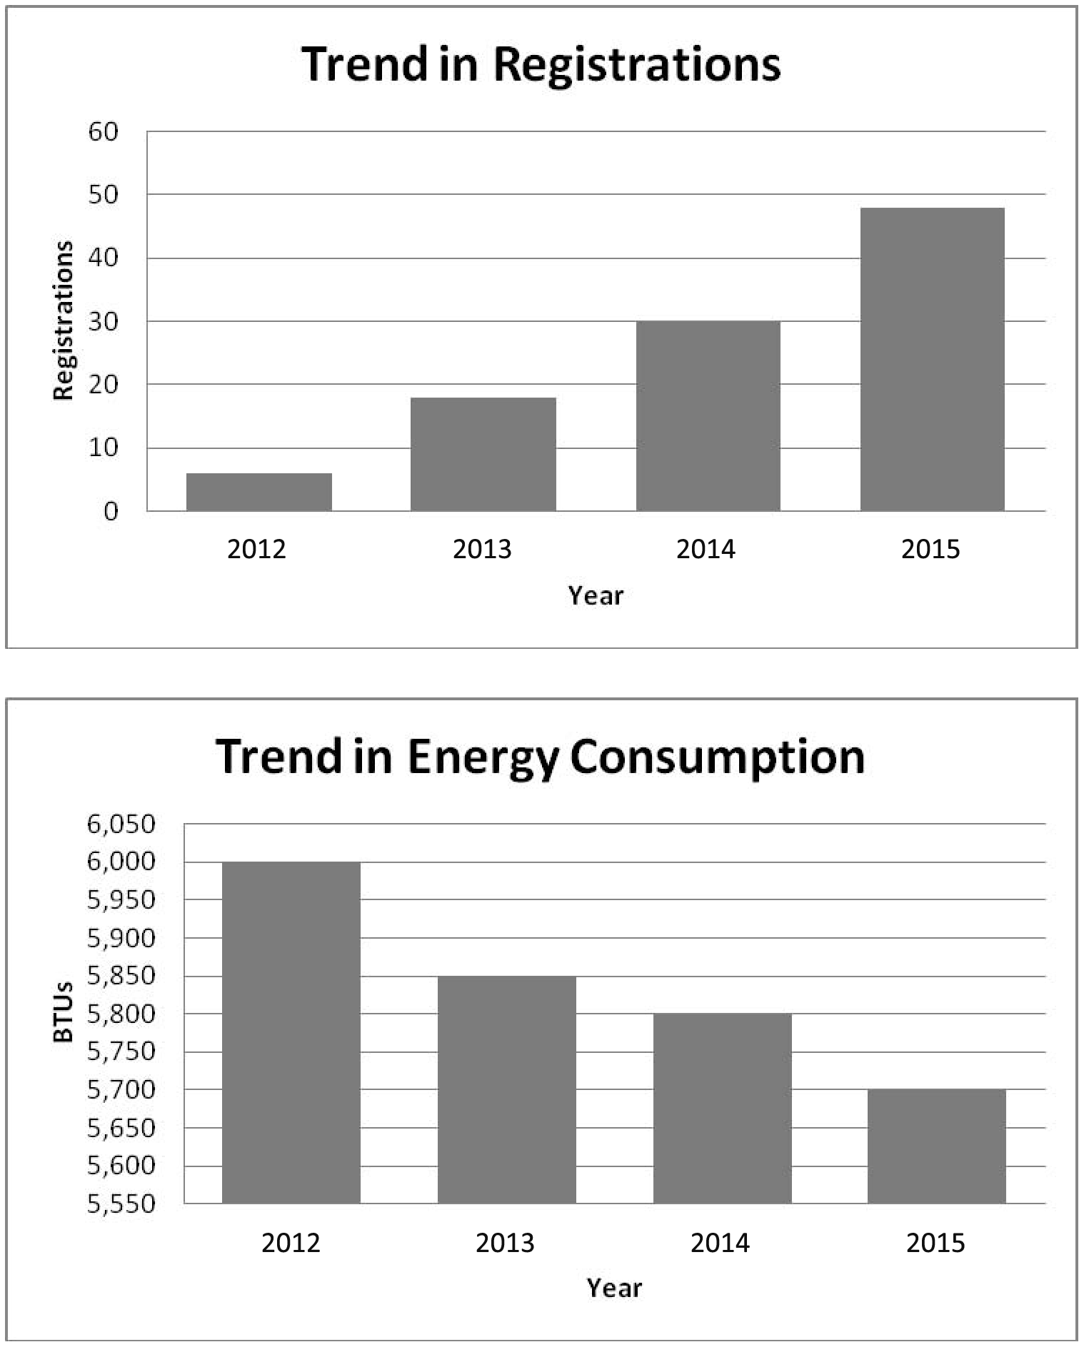

Problem 14.40 (Concluded)
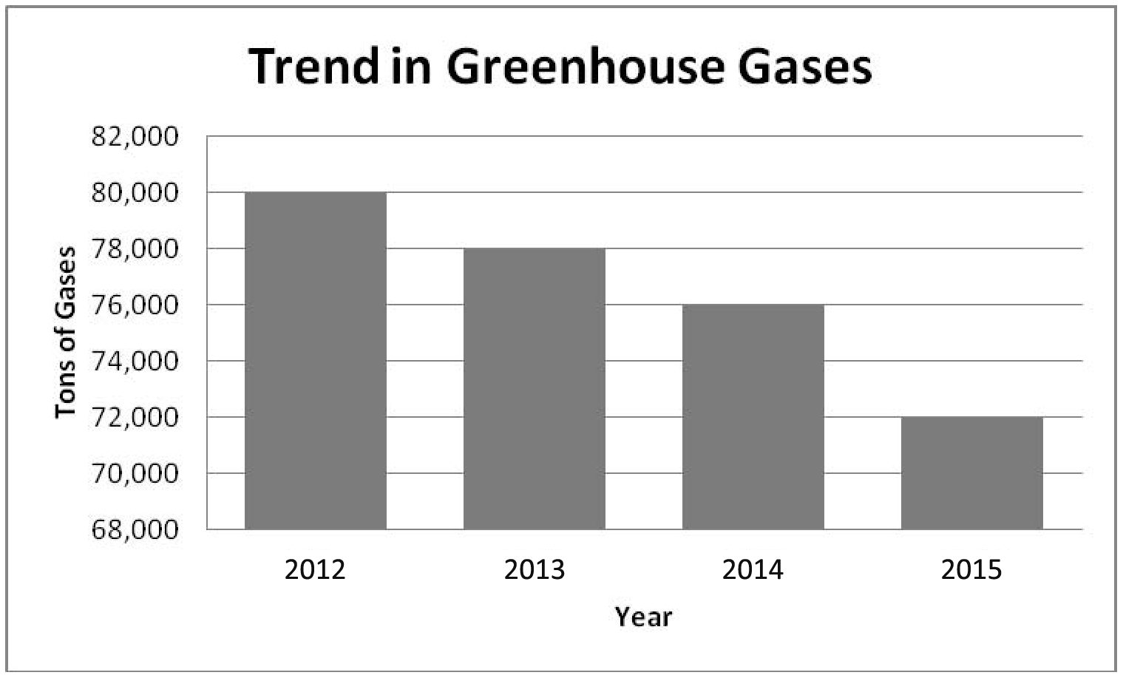

The trends are all favorable, signaling a marked improvement in environmental performance.

2.
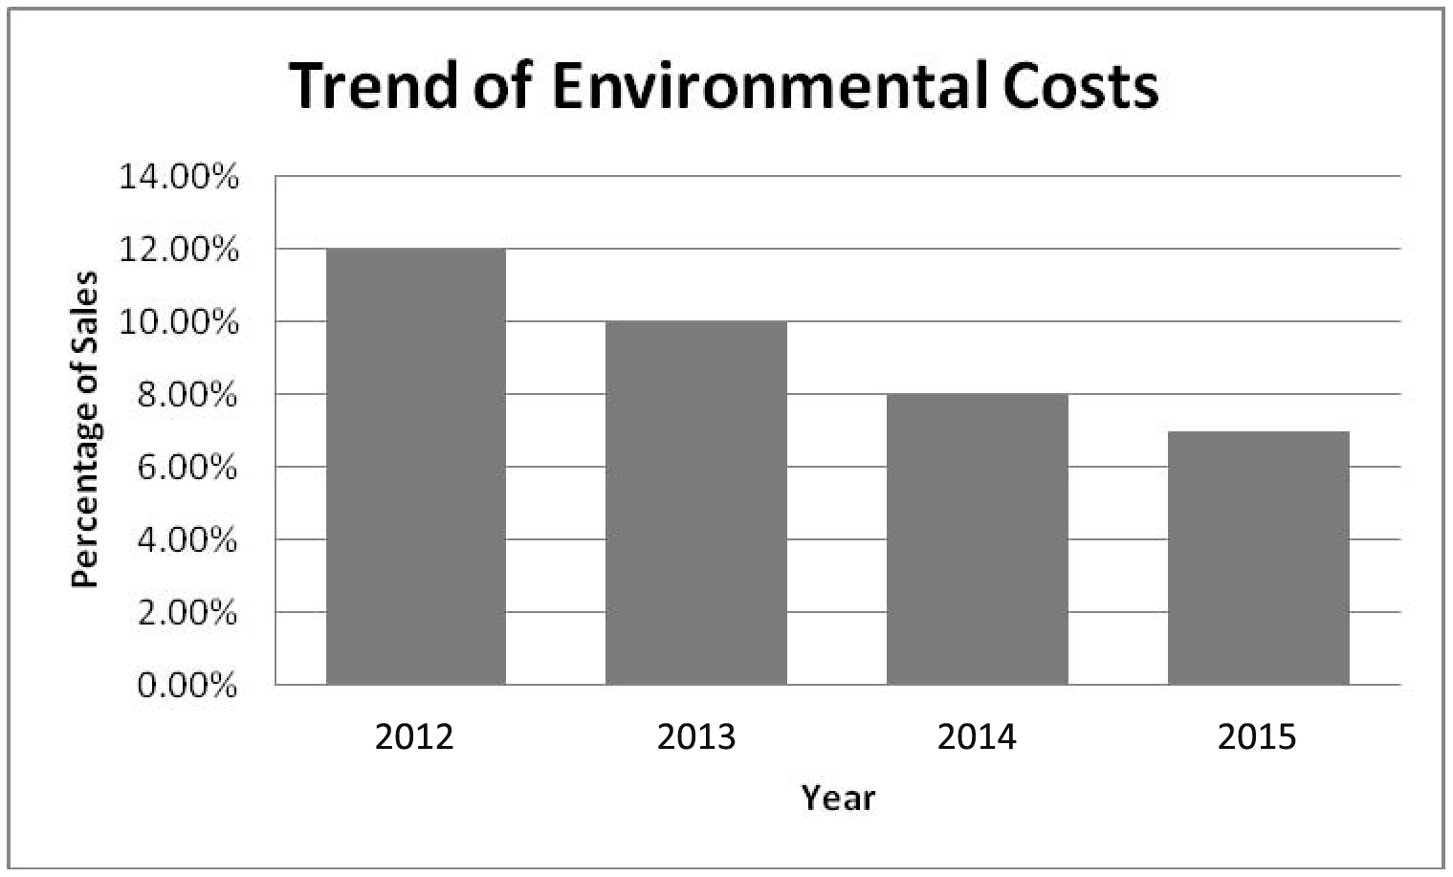

Environmental costs have decreased because environmental performance has improved (an ecoefficient outcome).

Problem 14.40 (Concluded)
3.
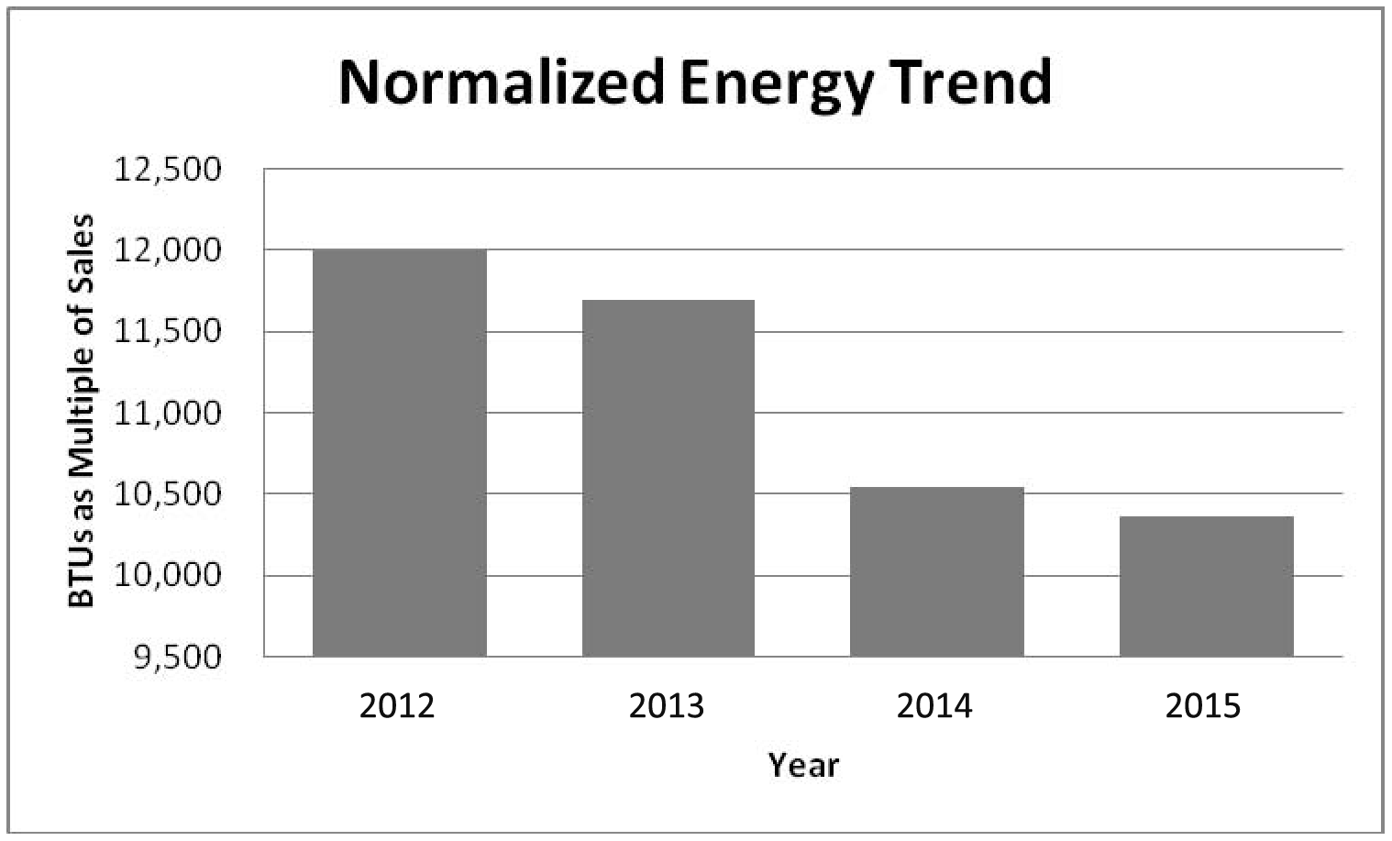

The progress in the reduction of energy consumption is positive (reflecting about a 13.6% decrease from the base year 2012 (10,364 – 12,000)/12,000)). This is a more dramatic reduction using the nonnormalized measure (which was about a 5 percent reduction [(5,700 – 6,000)/6,000). The normalized measure is better because it reflects the reality that energy consumption can vary with output; thus, any improvement should be measured adjusting for possible output changes.
Problem 14.41
1. Benefits category:

- Ozone depletion: external failure
- Hazardous waste disposal: external failure
- Hazardous waste material: internal failure
- Nonhazardous waste disposal: external failure
- Nonhazardous waste material: internal failure
- Recycling income: prevention
- Excessive energy usage: internal and external failure
- Excessive packaging: external failure

In all cases except for recycling, the underlying reduction activities should be largely prevention with some detection requirements. This reveals the importance of prevention in the ecoefficiency model. (Remind students of the 1–10–100 rule.)

Costs category:

- Corporate level: prevention
- Auditor fees: prevention and detection
- Environmental engineering: a cost that likely would be split among activities in four categories (using, for example, resource drivers)
- Facility: all four categories
- Packaging: prevention
- Pollution controls, operations and maintenance: internal failure
- Pollution controls, depreciation: internal failure
- Attorney fees: external failure
- Settlements: external failure
- Waste disposal: external failure
- Environmental taxes: external failure
- Remediation, on-site: external failure
- Remediation, off-site: external failure
Problem 14.41 (Concluded)
2. If ecoefficiency is true, then investing in prevention and control activities will drive the failure costs to very low levels. Moreover, the reductions in failure costs should significantly exceed the costs of prevention. Furthermore, the detection costs can also be eliminated eventually. Thus, over time, the environmental benefits category will grow and the environmental cost category will shrink.
Problem 14.42
1. 2013 2014 2015
Environmental benefits:
Ozone-depleting substances,
cost reductions* $ 1,080,000 $ 1,800,000 $ 2,880,000

Environmental costs:
Engineering design 1,440,000 720,000 90,000

*These amounts are cumulative:
Annual Cumulative
$3,240,000 – $
2,160,000 = $1,080,000 savings $1,080,000
$2,160,000 – $1,440,000 = $720,000 savings $1,800,000
$1,440,000 – $360,000 = $1,080,000 savings $2,880,000

2. In 2013, the cost reductions were less than the design cost. However, in the following year, the cost reduction achieved matched the design cost, and the reductions achieved in the prior year are costs avoided in 2014 as well. Thus, the total savings is $1,800,000, the sum of last year’s ($1,080,000) plus this year’s ($720,000). In 2015, the design costs are $90,000, and the pollution costs are reduced by an additional $1,080,000. Thus, the total savings per year now amount to $2,880,000 (the sum of the current-year savings plus the costs avoided from improvements of prior years). How much is an annuity of $2,880,000 worth? Certainly, more than the $2,430,000 paid for engineering design activity in 2012, 2013, 2014, and 2015! This seems to support ecoefficiency: improving environmental performance improves economic efficiency.
Problem 14.43
1. Kartel/Communications Products Division
Environmental Financial Statement
For the Year Ended December 31, 2015

Environmental benefits:
Cost reductions, hazardous waste $ 150,000*
Cost reductions, contaminant releases 250,000
Cost reductions, scrap production 50,000
Cost reductions, pollution equipment 130,000
Energy conservation savings 36,000
Remediation savings 210,000
Recycling income 25,000
Increased sales 200,000
Reduced insurance and finance costs 80,000
Total environmental benefits $ 1,131,000

Environmental costs:
Prevention:
Designing processes and products $ 100,000
Training employees 40,000
Detection:
Measuring contaminant releases 70,000
Inspecting processes 80,000
Internal failure:
Producing scrap 125,000
Operating pollution equipment 130,000
External failure:
Disposing hazardous waste 50,000
Releasing air contaminants 250,000
Using energy 144,000
Remediation 190,000
Total environmental costs $ 1,179,000

*$200,000 (2013) less $50,000 (2015), etc.

2. The total environmental costs in 2013 were $1,785,000. The total costs in 2015 were $1,179,000, which is a significant decrease. Adding to this the fact that sales increased because of an improved environmental image, financing and insurance costs decreased, and recycling income increased, then there is strong evidence of increased efficiency. Moreover, the ratio of benefits to costs in 2015 is approaching 1. Thus, ecoefficiency is working, and the firm is strengthening its competitive position.
Problem 14.44
1. Activity rates:

Hazardous waste: $200,000/200 = $1,000 per ton
Measurement: $10,000/5,000 = $2 per transaction
Contaminants: $500,000/250 = $2,000 per ton
Scrap: $175,000/50,000 = $3.50 per pound
Equipment: $260,000/520,000 = $0.50 per hour
Design: $50,000/2,000 = $25 per hour
Energy: $180,000/1,800,000 = $0.10 per BTU
Training: $10,000/100 = $100 per hour
Remediation: $400,000/20,000 = $20 per hour

Problem 14.44 (Continued)
Unit cost calculation:

Model XA2 Model KZ3
Hazardous waste:
$1,000 × 20 $ 20,000
$1,000 × 180 $ 180,000
Measurement:
$2 × 1,000 2,000
$2 × 4,000 8,000
Contaminants:
$2,000 × 25 50,000
$2,000 × 225 450,000
Scrap:
$3.50 × 25,000 87,500
$3.50 × 25,000 87,500
Equipment:
$0.50 × 120,000 60,000
$0.50 × 400,000 200,000
Design:
$25 × 1,500 37,500
$25 × 500 12,500
Energy:
$0.10 × 600,000 60,000
$0.10 × 1,200,000 120,000
Training:
$100 × 50 5,000
$100 × 50 5,000
Remediation:
$20 × 5,000 100,000
$20 × 15,000 300,000
Total assigned $ 422,000 $ 1,363,000
Divided by units ÷ 200,000 ÷ 300,000
Unit cost $ 2.11 $ 4.54*

*Rounded.

The unit cost information provides an index of the environmental performance of each product. Thus, it can serve as a benchmark for evaluating subsequent efforts to improve environmental performance. The unit environmental cost also provides some indication as to where environmental improvement activities should be focused.
Problem 14.44 (Continued)
2. 2013 costs for the three relevant items:

Model XA2 Model KZ3
Hazardous waste:
$1,000 × 20 $ 20,000
$1,000 × 180 $ 180,000
Contaminants:
$2,000 × 25 50,000
$2,000 × 225 450,000
Equipment:
$0.50 × 120,000 60,000
$0.50 × 400,000 200,000
Totals assigned $ 130,000 $ 830,000
Divided by units ÷ 200,000 ÷ 300,000
Unit cost $ 0.65 $ 2.77*

*Rounded.

2015 unit costs for the three items:

Model XA2 Model KZ3
Hazardous waste:
$1,000 × 10 $ 10,000
$1,000 × 40 $ 40,000
Contaminants:
$2,000 × 15 30,000
$2,000 × 110 220,000
Equipment:
$0.50 × 60,000 30,000
$0.50 × 200,000 100,000
Total assigned $ 70,000 $ 360,000
Divided by units ÷ 200,000 ÷ 300,000
Unit cost $ 0.35 $ 1.20

Note: The activity rates are calculated using 2015 costs and activity output and remain the same (e.g., $50,000/50 = $1,000 per ton for waste).

Unit cost reductions:

Model XA2: $0.65 – $0.35 = $0.30 per unit, or $60,000 in total
Model KZ3: $2.77 – $1.20 = $1.57 per unit, or $471,000 in total
Problem 14.44 (Concluded)
Both products appear to be cleaner than before, and this may be what contributed to the increased sales mentioned in Problem 14–38. Also, from the data in Problem 14–38, it appears that the design decision cost an extra $250,000 in 2014 and an extra $50,000 in 2015. Thus, $300,000 was spent to produce annual savings of $531,000. Of the $300,000, only $50,000 appears to be a recurring expense. Furthermore, the materials cost is reduced as well (how much is not given). It appears to be an economically justifiable decision.

cyber research case
14.45
Answers will vary.

The Collaborative Learning Exercise Solutions can be found on the
instructor website at http://login.cengage.com.

The following problems can be assigned within CengageNOW and are auto-graded. See the last page of each chapter for descriptions of these new assignments.

- Integrative Exercise—Activity Based Costing, Quality and Environmental Costing, Lean and Productivity Costing (Covers chapters 4, 14, and 15)
- Integrative Exercise—Balanced Scorecard, Quality and Environment Costing, Strategic Cost Management (Covers chapters 11, 13, and 14)
- Blueprint Problem—Costs of Quality, Quality Cost Report, and Interim Quality Performance Reports
- Blueprint Problem—Trend Reports, Long-Range Reports
- Blueprint Problem—Environmental Cost Management

